Chapter 11, Solution 20.

The load resistance R_{L} in Fig. 11.51 is adjusted until it absorbs the maximum average power. Calculate the value of R_{L} and the maximum average power.

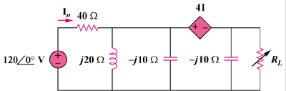

165∠0˚ V

Figure 11.51
For Prob. 11.20.

Solution

Combine j20 and -j10 to get .

To find , insert a 1-A current source at the terminals of , as shown in Fig. (a).

1 A

40

-j10

V₁

V₂

(a)
+

4 I_{o}

-j20

I_{o}
At the supernode,
(1)

Also, , where
(2)
Substituting (2) into (1),

To find , consider the circuit in Fig. (b).

40

-j10

V₁

V₂

(b)
+

4 I_{o}

-j20

I_{o}

+

V_{th}

1650 V
+

At the supernode,
(3)

Also, , where
(4)

Substituting (4) into (3),
150–j30

P_{max} = = 21.51 W

